Acceptance Testing
UAT Execution & Report Submission

Date | 10 February 2026
Team ID | LTVIP2026TMIDS24181
Project Name | ToyCraft Tales – Tableau’s Vision into Toy Manufacturer Data
Maximum Marks | 4 Marks

Purpose of Document
The purpose of this document is to explain the test coverage and system validation status of the ToyCraft Tales dashboard at the time of release to User Acceptance Testing (UAT).
It ensures that all dashboard functionalities, filters, KPIs, and visualizations meet business requirements.

Defect Analysis

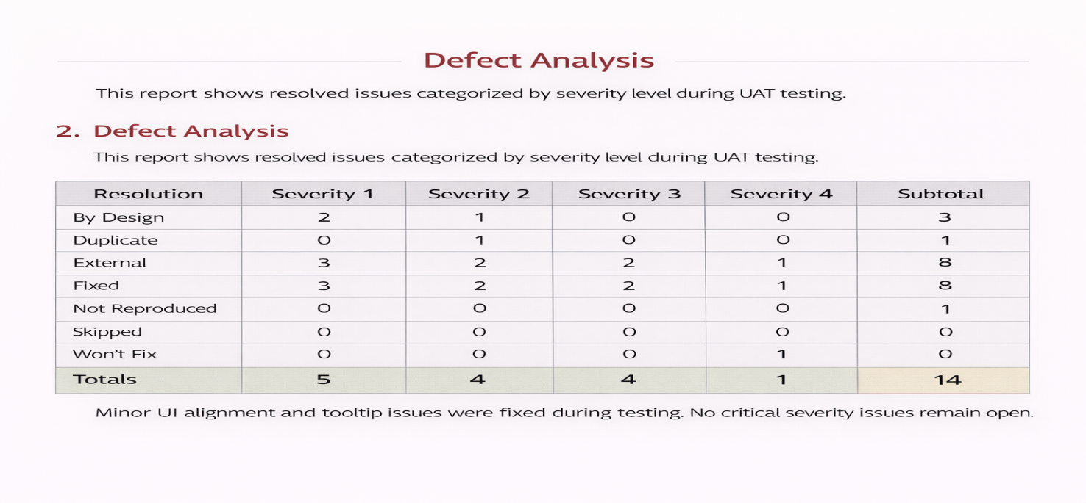

Test Case Analysis
